# Photography/Lighting notes

## Seeing the light

* Brightness
  + How much light you have affects the mood and clarity of the photograph
* Size
  + A large source produces a soft light and shadows. The smaller the light source, the harsher the light becomes, and the more distinct the shadows are.
* Color
  + It can add to the mood and expression of a photograph, but it can also ruin an image by discoloring the subject or background.
* Number of light sources
  + Working with multiple sources allows you to sculpt your subject.
* Distance
  + The distance from the source to the subject controls both the relative strength of the light and its relative size.
* Direction
  + It allows you to interpret the subject in many ways. It can reveal texture or smooth details.
* Quality:Hard, Focused or Diffuse(soft).
* Lights can be direct or hard, focused like a spotlight, or they can be soft and diffuse.
  + Hard light:
    - Produces strong, dramatic highlights and shadows unless diffused by user.
    - Can be used relatively far away from the subject.
    - Generally requires fill light to soften shadows and control contrast.
    - Brightness and spill are fairly easy to control.
  + Soft light:
    - Consists of a relatively large, indirect light source (ex-an overcast sky)
    - Produces gentle, flattering highlights and shadows.
    - Needs to be closer to the subject.
    - Tends to spill and reduce contrast.
    - Requires little or no fill light.
    - Works well as fill because it does not introduce hard shadows.

## 3 point lighting

## set key at 4:30 or 7:30

## 45 degrees up from the subject

## set backlight opposite the key

## set fill at 4:00 or 8:00 opposite the key

## less fill for more drama/harsher light

## keep back light off the lens

* optional 4th light for the background

## Inverse square law

Moving a light source twice as far away reduces the light by 4x (not 2x). In photographic terms, that translates into two f-stops, not one f-stop, to compensate. For example, an electronic flash placed 12 feet from your subject will provide one-quarter as much illumination as the same flash located just six feet from the subject. After moving the flash twice as far away, you'd have to open up two f-stops to keep the same exposure.

## Lighting ratios

For portraiture, you probably will want to use 3:1 or 2:1 lighting ratios for a softer look that lets the shadows define the shape of your subject without cloaking parts in inky blackness.

If you do need to know the lighting ratio, it's easy to figure by measuring the exposure separately for each light and multiplying the number of f-stops difference by two. A two-stop difference means a 4:1 lighting ratio; two-and-a-half stops difference adds up to a 5:1 lighting ratio; three stops is 6:1(8:1) and so forth.

## Main Light

The main light, or key light, is the primary light source used to illuminate a portrait. It may, in fact, be the only light you use, or you may augment it with other light sources. The main light is most often placed in front of the subject and on one side of the camera or the other. Some kinds of lighting call for the main light to be placed relatively high, above the subject's eye-level, or lower at eye-level. You usually won't put a main light lower than that, unless you're looking for a monster/crypt-keeper effect.

# Notes on portraiture

Strength

Keeps the viewers eye within the photo

Good for groups/singles

# Body pose

S curve feminine shape

Chin towards near shoulder, toe towards camera, weight on back leg, knee in a little

C curve masculine shape

Chin towards far shoulder/strength, dominate, strong

Expression is the most important part.

Character is expressed through posing of body, dress and use of props.

Expression – comes through eyes, hands and facial mood.

12 parts of body to pose

1 face

2 eyes

3 head

4 shoulders

5 arms

6 wrists

7 hands

8 fingers

9 hips

10 legs

11 ankles

12 feet

Oval face best

Eyes

Up – wonder, bored

Down – prayer, contemplation

Side – mistrust

# Types of flash

**Automatic flash** reacts to the amount of light reflected back from the subject during exposure.

**Dedicated flash** units are designed to be used with a particular camera.

Can be fooled by a subject that is too dark or does not fill enough of the frame, or if a subject is too close to a light background which reflects a lot of light.

**TTL: Through the Lens** is usually more accurate because it measures the light actually hitting the film/CCD. Depending on the camera, you may be able to set the ratio of flash to existing light.

**Manual Flash:** You set the light output manually.

## Tools to modify lights

**Barn doors**

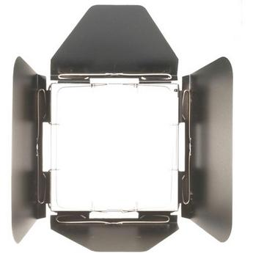

The 4 leaf barndoor set mounts directly onto the Profoto Zoom Reflector. It features springs for mounting filters and/or honeycomb grids. It blocks undesired light from the subject or the camera lens, and shapes the light output ofthe flash head, when used without the grids.

Barndoors, Snoots, Grids, and Filters are essential accessories for any lighting system. These devices alter the shape, intensity, or color of the light output from your flash heads. Consider them as a painter would a brush, or a sculptor would a knife, or chisel.

Use of a barndoor set will result in a shaft of light, when it is attached to the front of the reflector of your light source. The size of the shaft of light will be determined by the opening of the leaves, and the distance of the light from the subject. Rotating the barndoor set will determine the angle of the shaft of light. A 4-leaf barndoor provides more light control than a 2-leaf barndoor set.

**Snoots**

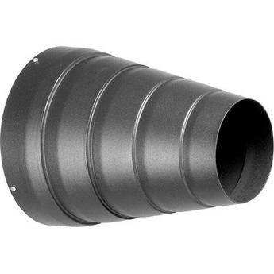

Mount this very narrow snoot to a Hensel flash head to achieve a very precise light output. Use it for highlighting a small, specific area of the subject, or background.

**Grids**

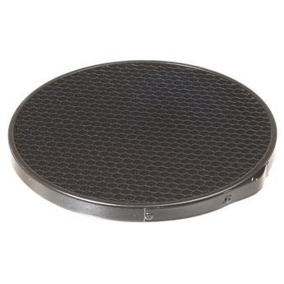

This Profoto Honeycomb 10 Degree Grid provides a beam spread of 10 when mounted on a Profoto zoom reflector. This grid mounts directly onto the Zoom Reflector 2.

Note: This grid requires a barndoor with grid holder, or a grid and filter holder kit for mounting on the older Profoto Zoom Reflector.

Grids are essential accessories for any lighting system. These devices alter the shape and intensity of the light output from your flash heads. Use of a grid will result in a small circle of light, when it is attached to thefront of your light source. The size of the circle of light will be determined by the density of the honeycomb, its thickness, and the distance of the subject.

**Soft Box**

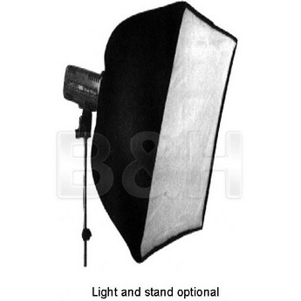

For soft and even lighting

# Types of portrait lighting

Untitled-2 Hatchet

half light half dark

Untitled-1 Rembrandt

triangle under eye, shadow touches cheek

# Portrait Lighting

## Short light/Loop Lighting

* Loop Lighting named for the loop shaped shadow of the nose
* Light is only slightly closer to camera axis than Rembrandt lighting
* Most common lighting
* Used with average oval faces as well as with round faces to thin them down.
* For heavier people
* Shadow nearer to camera
* Main light is on side away from camera if face is turned

## Broad/Long lighting

* Tends to widen features
* For thin or narrow faces
* Light side close to camera
* The main light is high so that the catchlight reflected in the eye is at 1 o’clock
* May make the side of the head or ear too bright. Use barn doors or flag.

## Butterfly Lighting

* Main light is directly in front and above subject.
* Conventionally used for glamour lighting.
* Main light is positioned high enough to create a symmetrical shadow under the nose but not so high that the upper lip or eye sockets are excessively shadowed.

## Corrective Portraiture notes

* Hide long side of face in shadow
* Avoid bright prints or patterns
* Flag foreheads
* Long chin up
* Crooked nose into camera
* Main light close to camera for wrinkles

## Lights

### Guide Number

fstop=Guide number/distance of light

f8=80GN/10ft

Or

**GN = f/stop x Flash-to-subject distance**

160GN/10ft=f16

Guide numbers are usually given for ISO 100 speed film

In addition to being an indicator of a flash’s power, guide numbers also can be used to calculate aperture settings and subject distances when using the camera and flash on manual mode as when you are using a flash not designed to work with the camera.

To calculate the f/stop needed, divide the guide number by the distance to the subject.

To calculate the maximum flash range, divide the guide number by the selected or largest f/stop.

When making these calculations, there are a few things to be aware of:

• It is the flash-to-subject distance that you use, not camera-to-subject. This is the same when using on-camera flash but not when using flash on a cable or a slave flash.

• Guide numbers are usually given for both feet and meters so be sure you use the right one in your calculations. The differences can be substantial. For example, a guide number of 12, when using meters as a unit of measure, is the same as a guide number of 39 when using feet. Conversions between a guide number for feet and a guide number for meters are:

**From meters to feet: GN(ft) = GN(m) x 3.3**

**From feet to meters: GN(m) = GN(ft) x 0.3**

**Watt second** is a term representing the measurement of the consumption of electric power.

Inverse square law: At 2 times the distance, an object receives 1/4 the light. Intensity of the illumination is inversely proportional the square of the distance from light to subject.

## Lighting notes and terms

* Umbrellas
* Bounce cards: You lose a half to one stop when you bounce. Light also has to travel a longer distance.
* Soft Box
* Balancing with daylight
* Recycle time
* Bounce light
* Diffuse light
* Raking light
* Side Lighting
* Back Lighting
* Flag or Gobo
  + Shades part of subject or camera lens(lenser)
* Scrim
* Main light
  + for contrast, depth and form
* Fill light
  + Close to camera, fills shadows
* Large/diffused
* Modeling Light
  + Constant light from the strobe head to show the lighting
* Rim or Hair light
  + In back opposite of main
* Kicker
  + Same side as main/catch light at 10 or 2
* Lighting ratio
  + 2:1 black
  + 4:1 white

# Types of Portrait lighting

**M**ost photographers are interested in portrait lighting but most seem not to understand how to do it. The techniques that we are going to discuss can be used with either hot lights or studio strobes. You can use these same concepts with flash units, however you will not be able to see the effect until after you shoot. With practice you will be able to control the harshness of the light as well as being able to de-emphasize problem areas, such as a narrow face or a round face. The wrong lighting will emphasize these features and will not be flattering to your subject. The right lighting will make your subject happy indeed.

|  |  |
| --- | --- |
| There are four main styles of lighting that we need to describe. The first is ***Broad Lighting.***Broad lighting is when the main light is positioned in such a way that it illuminates the side of the face that is turned ***toward*** the camera. This technique is used mainly for corrective purposes. It will de-emphasize facial features and is used mostly to make thin, narrow faces appear wider. |  |

|  |  |
| --- | --- |
| ***Short Lighting*** is when the main light illuminates the side of the face that is turned ***away*** from the camera. This technique is used when the subject has an average oval face. Short lighting emphasizes facial contours more than broad lighting. This style can be adapted for a “strong” or “weak” look by using a weaker fill light. This *narrow lighting* (as it is sometimes called) is especially good for use in low-key portraiture. Because short lighting has a narrowing effect, it is great for use with subjects that have particularly round or plump faces. |  |

|  |  |
| --- | --- |
| ***Butterfly Lighting***(or Paramount Lighting) is achieved by positioning the main light directly in front of the subjects face and adjusting the height to create a shadow directly under, and in line with, the nose. This style is best suited for subjects with a normal oval face and is considered to be a glamour style of lighting best suited for women. It is not recommended for use with men because it has a tendency to highlight the ears – crating an undesirable effect. |  |

|  |  |
| --- | --- |
| The fourth style of lighting is ***Rembrandt Lighting****.* Rembrandt lighting is obtained by **combining short lighting and butterfly lighting**. The main light is positioned high and on the side of the face that is away from the camera. This technique produces an illuminated triangle on the cheek closest to the camera. The triangle will illuminate just under the eye and not below the nose. |  |

|  |  |
| --- | --- |
| The positioning of the main light is usually about 45 degrees from the camera-subject axis and should be slightly higher than the subject. A good method to determine proper placement of the main light is to look at the catchlights in the subject’s eyes. The catchlights should be at either the one o’clock or eleven o’clock position. Depending on your subject, the height of the light may need to raised or lowered to get the catchlights in the eyes. This is fine. |  |

|  |  |
| --- | --- |
| Without catchlights the eyes look too dark and recessed; giving the eyes a lifeless look. |  |

|  |  |
| --- | --- |
| You normally place the fill light on the opposite side of the camera from the main light. The fill light also needs to be a much lower power unit than the main light. If you use too much fill you’ll loose the effect of the lighting style. The purpose of the fill light is to add just enough light to soften the shadows created by the main light.  **The fill light is used to control contrast.** By increasing the power of the fill you reduce the contrast in the photo. By decreasing the amount of light from the fill, you will increase contrast. When setting the distance of your fill light watch how noticeable the shadow from the main light is. This will be your guide to how noticeable it will be in the final image. The fill light will almost always add a second lower pair of catchlights. This is usually objectionable because it gives the impression that the subject has a directionless stare. This second pair of catchlights should be retouched from the final photo. Also watch for reflections if your subject wears glasses. You may have to reposition the fill light slightly to eliminate eyeglass reflections. |  |

|  |  |
| --- | --- |
| Once the lights are in position, you can now play with the accessories we talked about in March to add the touch or feel that you are looking for. Bare light sources usually have a harsh effect and drown out details. Using umbrellas will soften the light and help maintain details. Barndoors or gobos can be used to control how much light, if any, is allowed to spill onto your background. An umbrella was used for this shot |  |

If you get daring enough to use a hair light cones and snoots will allow you to control the light so that it only illuminates the hair and doesn’t spill onto the shoulders and face of your subject. The hair light is a lower power light that illuminates the subjects hair providing separation from the background. This is especially important when photographing a subject with dark hair against a dark background. To properly place a hair light, you should bring the light forward enough to let the light spill onto the subjects face, then slowly move it back until the light disappears from the subjects skin.

Background lights can be used to illuminate the background, gaining more depth or separation in your image. This light is usually placed low to the ground on a small stand about half way between your subject and the background. A low power light is generally used. You can dramatically change the look of the shot by adding a gel to background light. Just remember when using gels you have to use a stronger light to compensate for the illumination being lost through the gel.

|  |  |
| --- | --- |
| Once you have placed all your lights in their proper locations, added the needed accessories to them, and have gotten a general feel for the way the shot looks, you can use a reflector card to add a soft, supplemental light to areas that may still appear too dark. Some of these cards have a gold side that you can use to add a warm glow to the photograph. Others, like the one used in this shot, have a silver side to provide more neutral fill light.  The reflector cards do not need another light source, as they will reflect the light that is already there. To find the proper location for the card, just move it in and out from a spot to see the effect. It will be noticeable to the naked eye. |  |

It is not necessary to use all of these accessories and techniques together. For the most part they can be mixed and matched to get whatever result you’re after. Although it sounds complicated with a little practice light placement becomes second nature and you’ll develop a setup that you’re comfortable with. It’s when you need an effect you can’t get with your normal set-up that you’ll need some of these additional lights and accessories.

Hopefully these articles will give you a better understanding of what equipment you might need and how to use it. Keep in mind there is nothing wrong if a simple setup/technique gives you the result you are looking for. Too many people think that lighting has to be complicated. Practice and experimentation will tell you what works best for you and I promise it gets easier after the first few times.